
PB2/GEQP/1222/A 12-JAN-2023
PREBOARD EXAMINATION - II (2022-23)
Subject: GEOGRAPHY  Grade: XII |  | Max. Marks: 70  Time: 3 Hours
GENERAL INSTRUCTIONS-
Question paper is divided into 4 sections A ,B,C&D
In section A question number 1 to 17 are MCQ type questions.
In section B question number 18-23 are SA type questions(80-100 words). Question 18 & 19 are Source based questions.
In section C question number 24 to 28 are Long Answer based questions (120-150 words).
In section D question number29 & 30 are Map based questions having 5 sub parts.
SECTION A
There are 17 questions in this section. All are mandatory.
1. | The Trans–Continental Stuart Highway runs between ……………… | 1
(a) Darwin and Melbourne
(b) Edmonton and Anchorage
(c) Vancouver and St. John’s City
(d) Chengdu and Lhasa
2 | Which of the following pairs is matched correctly? | 1
NAME OF THE COUNTRY OIL PORT
a. Tunisia Tripoli
b. Lebanon Esskhira
c. Venezuela Maracaibo
d. Oman Aden
3. | To which of the following regional bloc does South Asia belong to? | 1
 | (a) SAFTA
 | (b)NAFTA
 | (c) LAIA
 | (d) OPEC
4. | Which of the following is the first mega city in world? | 1
(a)Tokyo
(b)London
(c)New Delhi
(d)New York
5 | Assertion (A): Level of income reflects the level of freedom an individual enjoys.  Reason(R): Higher the level of income, the higher is the level of human development. | 1
(a) (A) Both A and R are true, and R is the correct explanation of A.
(b) Both A and R are true, but R is NOT the correct explanation of A.
(c) A is true but R is false.
(d) A is false and R is true

6 | Arrange the following approaches in a sequential order according to their development.  Choose the correct option.  1. Spatial organization  2. Regional approach  3. Areal differentiation  4. Humanistic approach |  | 1
(a) 1 4 2 3
(b) 4 1 3 2
(c) 2 3 1 4
(d) 3 2 4 1
7 | Assertion (A): Market gardening and horticulture specialise in the cultivation of high value crops such as vegetables, fruits and flowers, solely for the urban markets.  Reason (R): It is both labour and capital intensive and lays emphasis on the use of irrigation, HYV seeds, fertilisers, insecticides, greenhouses and artificial heating in colder regions. |  | 1
(a) (A) Both A and R are true, and R is the correct explanation of A.
(b) Both A and R are true, but R is NOT the correct explanation of A.
(c) A is true but R is false.
(d) A is false and R is true
8 | Which one of the following is not an objective of free trade? |  | 1
(a) Liberalisation of Trade
(b) Removal of trade barriers
(c) Increasing global competition
(d) Increasing custom duty
9 | Arrange the countries from the highest to the lowest on the basis of total railway network.  (i)India  (ii) Russia  (iii) China  (iv) United States of America |  | 1
 | (a) i, ii, iii, iv | (b) iv, iii, ii, i
 | (c) iii, ii, iv, i | (d) iv, iii, I, ii
10 | Assertion (A): The household industry is the smallest unit of manufacturing, also known as a cottage industry.  Reason (R): It is basically run by creative individuals or craftsmen who are assisted by their family members in their home |  | 1
(A) Both A and R are true, and R is the correct explanation of A.
(B) Both A and R are true, but R is NOT the correct explanation of A.
(C) A is true but R is false.
(D) A is false and R is true
11. | What is the range of value taken by HDI ? |  | 1
a) 0-1
b) 1-5
c) 5-10
d)0-10

12. | Which one of the following mineral is known as brown diamond? |  | 1
a) Iron
b) Mica
c) Lignite
d) Manganese
13. | Which one of the following nature of job is not matched correct |  | 1
- Red | People engaged in primary activities
- Blue | People involved in manual labour
- Black | People have specify skills and knowledge
- White | Professional workers

A)i
B)ii
C)iii
D)iv
14 | Which one of the following urban agglomeration has the highest share of in migrant population? |  | 1
(A) Mumbai UA
(B) Bangalore UA
(C) Delhi UA
(D) Chennai UA
 | Read the following case study and answer question no 15 to 17.
 | The level of urbanisation is measured in terms of percentage of urban population to total population. The level of urbanisation in India in 2011 was 31.16 per cent, which is quite low in comparison to developed countries. Total urban population has increased eleven-fold during the twentieth century. Enlargement of urban centres and emergence of new towns have played a significant role in the growth of urban population and urbanisation in the country. But the growth rate of urbanisation has slowed down during last two decades. Urban centre with population of more than one lakh is called a city or class I town. Cities accommodating population size between one to five million are called metropolitan cities and more than five million are mega cities. Majority of metropolitan and mega cities are urban agglomerations
15 | How much has the urban population increased during the 12th century?  (A) nine folds  (B) ten folds  (C) eleven folds  (D) twelve-folds |  | 1
16 | What was the level of urbanisation recorded in India in 2011?  (A) 31.14 %  (B) 31.15%  (C) 31.16%  (D) 31.17% |  | 1
17 | What are the main features of the Smart Cities Mission?  (A) provide core infrastructure  (B) stop migration  (C) encourage educated people  (D) All of the Above |  | 1

SECTION B
Question numbers 18-23 are SA type questions. Question 18 & 19 are Source based questions.
18. Study the diagram and answer the following questions based on distribution of urban population
 | 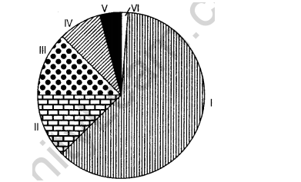
18.a | Into how many classes are urban centres classified by the census of India? |  | 1
18.b | Which class of urban centres has the largest and lowest urban population? |  | 1
18.c | What is the population size of class V cities? |  | 1
19. | Observe the given map and answer the following questions:
 | 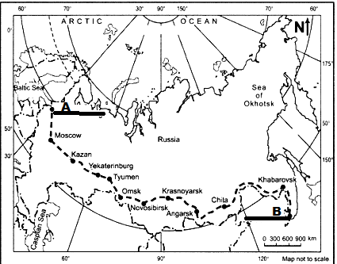
19.1 | Identify the railway line shown in the map. |  | 1
19.2 | Name the station marked on the map –A and B |  | 1
19.3 | Name the continents connected with this route |  | 1
20 | Describe the socio-cultural problems associated with urban settlements in the developing countries. |  | 3
21.a | ‘Development has direct bearings on the deteriorating human conditions’. How poor people are more affected in this process? |  | 3
 | OR
21.b | Describe the concept of Human Development as defined by United Nations Development Programme (UNDP)
22. | ‘India is endowed with fairly abundant resources of iron ore’, write a brief note on distribution of Iron ore in India. |  | 3
23. | Study the map given below and answer the questions that follows  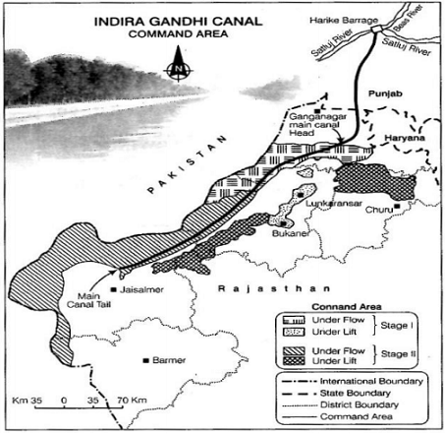 |  | 2+1
a.  b | What is the difference between the two areas shown as ‘Under Flow’ and ‘Under Lift’ system of irrigation.  Name the districts that are benefited by the command area of the canal in stage I and stage II.
SECTION C
Question numbers 24 to 28 are Long Answer based questions.
24.a | The challenge of sustainable development requires integration of quest for economic development with environmental concerns. Comprehend the statement in relation to the development of non-conventional sources of energy in India by giving suitable example. |  | 5
 | OR
24.b | Distinguish between metallic and non-metallic minerals and write a brief note on distribution of Iron ore in India. ( 2+3)
25.a | What is manufacturing? Explain three groups of industries classified on the basis of their size. |  | 1+4
 | OR
25.b | How do the tertiary occupation helpful in the economic development of a country ? Explain with suitable example .
26.a | ‘‘Mediterranean agriculture is highly specialized commercial agriculture in the world.’’ Support the statement. |  | 5
 | OR
26.b | ‘‘Dairy farming is the most advanced, efficient and capital-intensive type of farming in the world.’’ Support the statement.
27. | Define the term ‘density of population’. Elaborate any four geographical factors that influence the distribution of population in the world. |  | 5
28 | What is the significance of water transport ? Describe any three important features of the ‘North Atlantic Sea Route’ |  | 2+3
SECTION - D
MAP QUESTIONS
Question numbers 29 & 30 are Map based questions having 5 sub-parts each
 | On the given political map of the world, the following six features are shown. Identify any five of these features and write their correct names on the lines marked near each feature. |  | 5
A | An area of dairy farming in the world
B | One major sea port of Norway
C | An international airport in Chile
D | The largest country in South America
E | The western terminal station of Trans-Canadian Railway
F | An inland water way
30 | On the given political map of India, locate and label any five of the following with appropriate symbols : |  | 5
a)State with highest urbanization
b) Leading state in coffee production
c) Busiest sea port in the East coast of India
d) International airport in Tamil Nadu
e) Eastmost Metropolitan city connected by Golden Quadrilateral.
f) Oldest Copper mines of Rajasthan

Name: Section: Roll No:
WORLD -POLITICAL

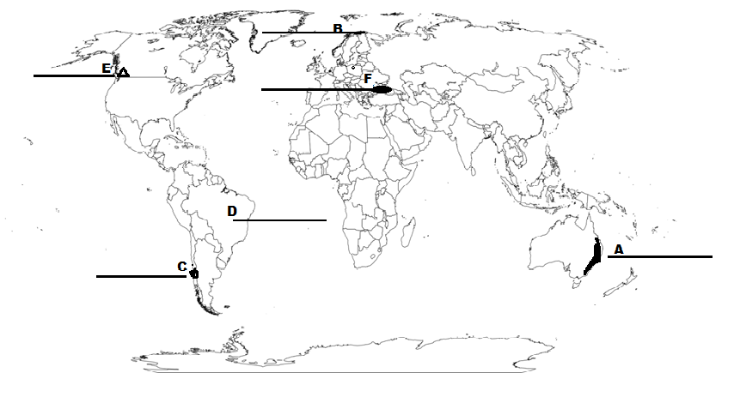

(Note: Attach both the maps to the answer sheet)

Name: Section: Roll No:

INDIA- POLITICAL
